Concepts Of Operation

Văn Lang Admissions

# Revision Table

|  |  |  |  |
| --- | --- | --- | --- |
| Author | Date | Reason for changes | Version |
| Minh Doan  Tai Nguyen | 08/12/2016 | Initial the document | 1.0 |
| Minh Doan | 13/12/2016 | Fix data and add Current Support Environment | 1.1 |
| Minh Doan | 8/1/2017 | Fix data | 1.2 |
| Minh Doan + Tai Nguyen | 15/1/2017 | Fix data + Update Context Diagram | 1.3 |
|  |  |  |  |

Table of Contents

Revision Table 1

1. INTRODUCTION 3

1.1. Purpose 3

1.2. Audience 3

2. Context System 3

3. Current System and Situation 4

3.1. Background, Objective and Scope 4

3.2. Current Users and Stakeholders 4

3.3. Current Support Environment 4

4. Justification and Description of Changes 4

4.1. Justification and Description of Changes 4

4.2. Priorities among changes 4

5. Proposed System Or Situation 5

5.1. Background, Objective and Scope 5

5.2. Operational Policies and Constraints 5

5.2.1. Technical constrains 5

5.2.2. Environment constrains 5

5.3. Description of PRoposed System or Situation 6

5.4. anticipated Users and Stakeholders 7

5.5. Quality Attributes 8

6. Scenario 8

7. Summary of Impacts 9

7.1. Operational Impacts 9

7.2. Impacts During Development 9

8. Analysis of Propose System 9

8.1. Summary of Improvements 9

# INTRODUCTION

## Purpose

* This document describes the characteristics of the system from the perspective of end user.

## Audience

|  |  |
| --- | --- |
| Intended Audience | Description |
| Project Manager | Manage development team and check the document before that document is shown to customers |
| Customer | Makes requests for development team and checks document |
| Project Team | Collect and analyze requests to write document |

# Context System

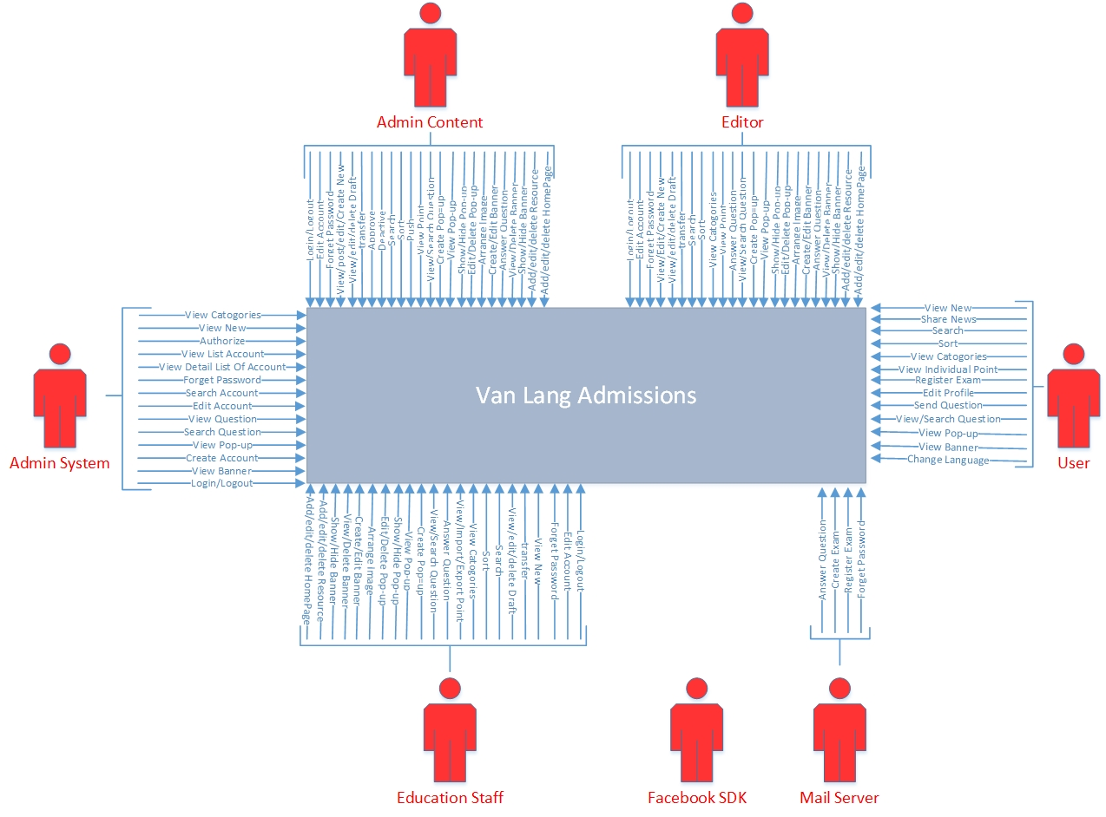

# Current System and Situation

## Background, Objective and Scope

* Currently, customer is using a website to manage the admission of Văn Lang University. But this website is created by discrete functions, each function is a website not uniform and use different programing languages.
* Current website is used by admin, editor, education staff and Users.

## Current Users and Stakeholders

* Current users: Admin, User, Editor, Education staff.
* Current stakeholders: Admin, User, Editor, Education staff.

## Current Support Environment

* Framework: DotNetNuke.
* Programming language: JavaScript, ASP.Net.
* To use the current system, users must use a computer running window7 +.

# Justification and Description of Changes

## Justification and Description of Changes

* Current website includes discrete websites implement different functions are created by different programing languages. Proposed website will integrate functions to be only one website with the same programing language.

## Priorities among changes

|  |  |  |
| --- | --- | --- |
| Modul | Description | Priority |
| Manage Accounts | This module help user manages account of system | High |
| Manage News | This module help user manages all the news on website | High |
| Manage Categories | This module help user manages all Categories of website | High |
| Manage Examination | This module help user manages about issues related to examinations | High |
| Manage Q/A | This module help user manages Q/A | High |
| Manage Pop-ups | This module help user manages Pop-ups | High |
| Manage Banners | This module help user manages Banners | High |
| Change Languages | This module help user change languages | Medium |
| Manage Homepage | This module help user manages Homepage of Van Lang Admission | High |

# Proposed System Or Situation

## Background, Objective and Scope

* Currently, customer is using a website to manage the admission of Văn Lang University. But this website is created by discrete functions, each function is a website not uniform and use different programing languages. So customer want BSS-Team to create a website includes the functions are uniformly and the same programming language.
* Proposed website is created by BSS-Team can help customer manage the admission of Van Lang University.
* BSS-Team develop project in 30 weeks from 01/10/2016 to 30/04/2017.

## Operational Policies and Constraints

### Technical constrains

* Database: mongodb, elasticsearch, redit
* Programming language: JavaScript
* Framework: AngularJs
* Platform: NodeJs

### Environment constrains

* Window 7+, Lightweight computer configuration (Core i3, Ram2gb…)
* Support of network traffic, high bandwidth.

## Description of PRoposed System or Situation

* With proposed system, we can integrate all function into a language. Get more additional some new function. Optimization system. To get more descript proposed system, we have a function list.

|  |  |
| --- | --- |
| Function LV 1 | Function LV 2 |
| Manage Accounts | Log-in |
| Log-out |
| Create Account |
| Edit Account |
| Search Account |
| Forget Password |
| View Detail Of Account |
| View List Account |
| Authorize |
| Activate Account |
| Deactivate Account |
| Manage News | Create News |
| View News |
| Post |
| View Draft |
| Edit Draft |
| Delete Draft |
| Transfer |
| Approve |
| Deactivate |
| Search |
| Sort |
| Push |
| Manage Categories | View |
| Add |
| Edit |
| Delete |
| Manage Examination | Create Exam |
| View point |
| View individual point |
| Register Exam |
| Import point |
| Export profile |
| Edit profile |
| Manage Q/A | Send question |
| Answer question |
| View question |
| Approve question |
| Search Question |
| Manage Pop-ups | Create |
| View |
| Show-Hide |
| Edit |
| Delete |
| Arrange images |
| Manage Banners | Create |
| View |
| Show-Hide |
| Edit |
| Delete |
| Arrange images |
| Manage Languages | Change Language |
| Manage Homepage | Create |
| Edit |
| Delete |

## anticipated Users and Stakeholders

* Customer
* BSS-Team
* User
* Admin System
* Admin Content
* Editor
* Education Staff

## Quality Attributes

* High: Performance, Availability, Scalability.
* Medium: Portability, Usability, Modifiability.
* Low: Security.

# Scenario

* Actors can log in or log out website with user’s account, additionally Admin can create, edit or search new account. In other hand, Actors find password by forget password function, Admin can view list of accounts and authorizes that account, Admin can view list of accounts and authorizes that account
* When the post is transferred and approved if the new have problem, actors will fix it. Actors can view, edit or delete draft of the post. Admin can approve the post from someone transfers to him. Admin can deactivate the news.
* Actors can search the news which they want to read, actors can sort the new follow the alphabet, posted date. Admin can push the news to the top. Actors can view the categories. Admin can add, edit or delete new category. Actors can view list points of candidates
* User can register skill examination. Education staff can import list of point into the system. Education can staff exports profile of candidate. User can edit profile. User can send the question. Actors can answer the question to User and the answer will be send to admin. Actors can view the approved question. If the question and the answer are good, admin will approve and post it. Actors can search the question which is posted. Actors can create, view, show or hide, edit, delete, arrange images new pop-up.
* Actors change language
* Finally, Actors can create, view, show, edit, delete, arrange images banner.

|  |
| --- |
|  |

# Summary of Impacts

## Operational Impacts

* Take time to learn how to use website.
* Add more new functions.
* More easy to use.
* Change data storing
* Search fast.

## Impacts During Development

* Programing is based on the new platform.
* Must study new programing languages.

# Analysis of Propose System

## Summary of Improvements

* BSS team will summarize the proposed new system and provides and disadvantages and limited.

## The proposed improvements

* Easy to use.
* Management the website system.

## Disadvantages and limited

* When the network connection is lost can’t access website

## The selection for change

* For these the functions not in the main functions of the software, there is a low priority, if users want to add more negotiation is needed, depends greatly on the ability and time.